RICHA RAGHAVENDRA – COMPUTER NETWORKS LAB WEEK 2

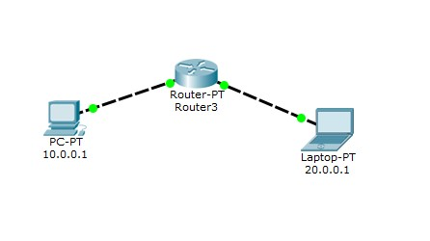

LOSS:

REQTIME OUT:

dest host unreachable:

SENT:

